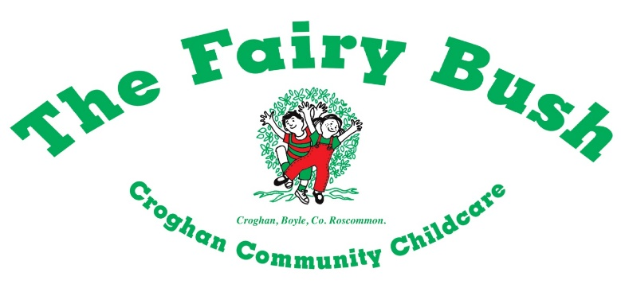

***Croghan Fairy Bush Ltd are currently recruiting candidates for the following positions:***

***Early Years Educator (Part-Time Position)***

Requirements

* Minimum Childcare FETAC Level 5 or equivalent.
* Good communication skills.
* Desirable - Child Protection and First Aid Response

***Early Years Educator (Full-Time Position)***

Requirements

* Minimum Childcare FETAC Level 5 or equivalent.
* Good communication skills.
* Desirable - Child Protection and First Aid Response

**Deadline for these applications is 15th October 2021**

**Applications with CV may be addressed to the Manager, Croghan Fairy Bush Ltd, Carrowmore, Croghan, Boyle, Co Roscommon or by email to** [**croghanfairybush@yahoo.ie**](mailto:croghanfairybush@yahoo.ie)

**For further information please contact the Manager on 071 9668400**

**\*All applicants must supply suitable character references and be prepared to complete a Garda vetting application form\***

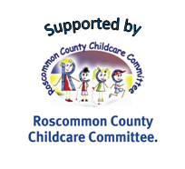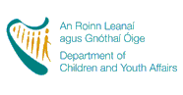pobal logo